Myles J Sartor
Matthew Griffin
STAT100-0121
19 September 2023
Problem Set 2
Code Console for 1a-1b-1c.:
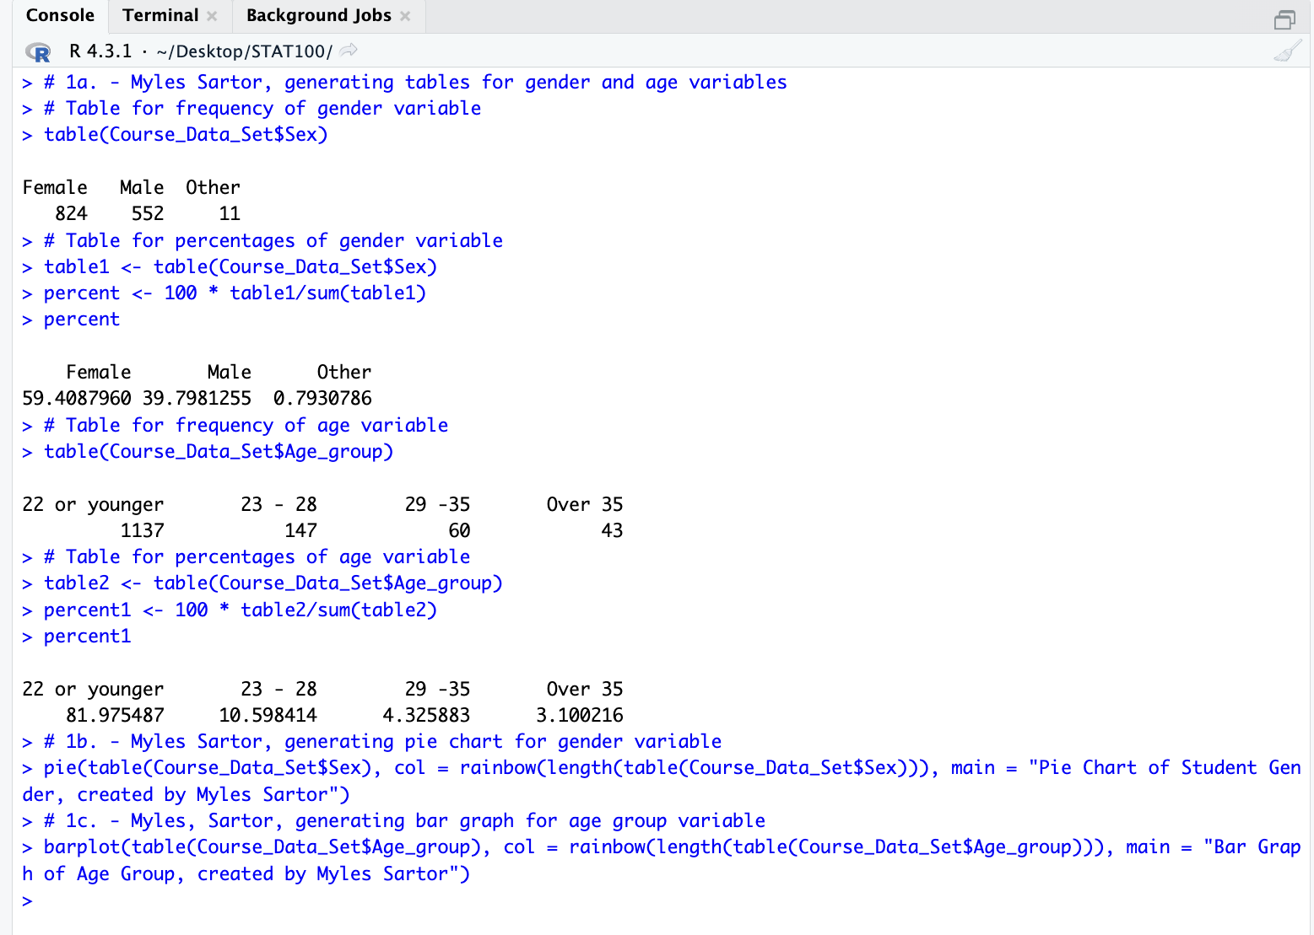

Graphs/Plots for 1b. and 1c.
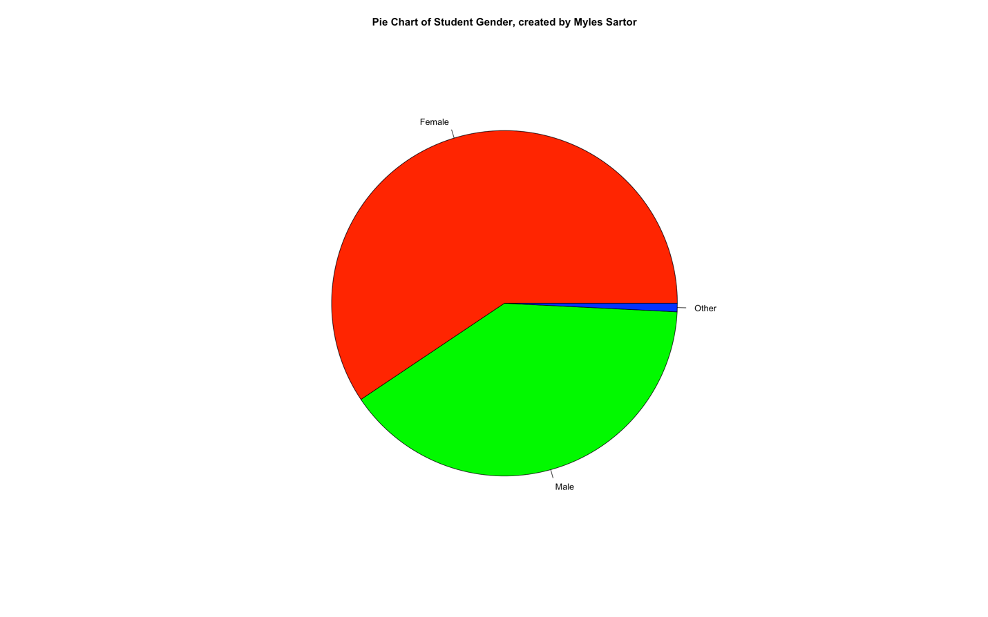
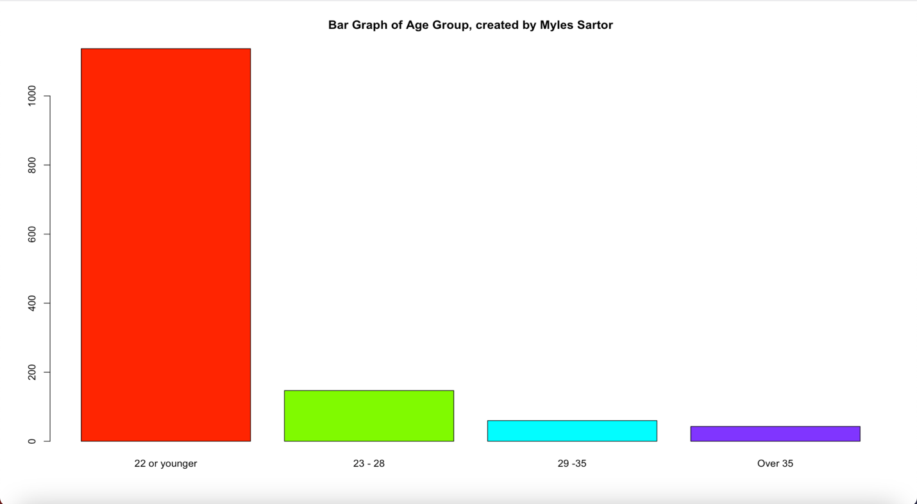

1d. By using the data summarized in the data displays, I can see that 563 students do not identify as female when I add up the number of students that identify as male or other (552+11). I checked this by subtracting the 563 students who don’t identify as females from the total number of students (1387). Since I got the female population of 824 as my result, I knew I had the correct arithmetic beforehand.

1e. By using the data summarized in the data displays, I can see that 7.426099 % of students are older than 28 when I add up the percentage of students between 29 and 35, and the percentage of students over 35 (4.325883 + 3.100216). I also get 7.426099 % when doing 60 + 43 / 1387 * 100 (number of students between 29 and 35 plus the number of students over 35 divided by the entire age group times 100, giving the percentage over the age of 28).

